MINISTRY DESCRIPTION – ASSISTANT TEACHER

Philosophy Statement
“Play, Learn, & Grow . . . in Jesus”
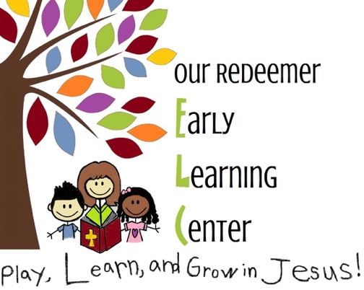

Organizational Overview
Our Redeemer Early Learning Center is a ministry of Our Redeemer Lutheran Church. The mission of the ELC is to provide quality care in a loving, nurturing, Christ-centered environment.
The role and function of the ELC School Board is to oversee all aspects of the school related to vision, finances, curriculum, and personnel. The School Board is also accountable to the State of Kansas as it pertains to licensing and regulations concerning operation. The School Board works with the ORL Church Council for performance expectations and direction.
The ELC School Board delegates to the ELC director the responsibility for the daily operation of the school. The program must be administered and supervised in accord with the policies adopted by the School Board.
The classroom teachers report to the director, with the classroom assistant teachers taking daily direction from the lead teachers.

Purpose
To assist the lead teacher in providing a loving and nurturing, Christ-centered environment in which the children can grow spiritually, physically, emotionally, socially, intellectually, and physically.

Job Summary
Performs the duties and responsibilities listed below in a competent, courteous, personable, and professional manner. He/she understands their role as teaching about the love of Jesus through positive role modeling, a gentle and consistent temperament, and caring relationships.

Reports to: Lead Teacher, Director, ELC Executive School Board, Elders of the church
Interfaces with: Director, parents, students, ELC staff, pastors
Job Classification: Regular part-time (<30 hours/week), non-exempt
Location: Our Redeemer Early Learning Center, Hutchinson, KS, with occasional travel for conferences or continuing education

Qualifications
Minimum  Requirements: | - Is at least 16 years of age  - Is an active member of a Christian church and sees his/her role as a calling for ministry, understanding the mission of the school  - Demonstrates a sincere desire to aid all students  - Demonstrates reliability with dependable attendance record and demonstrates competence in working effectively without close supervision  - Has an acceptable background check and health assessment
Physical  Requirements: | - Has strength for occasional lifting of students or physically aiding them in various ways.  - Has aptitude for occasional sitting on or near the floor  - Demonstrates emotional stamina and maturity
Skills and  Abilities: | - Establishes and maintains cooperative professional relationships  - Exhibits a passion for interacting with children, and demonstrates patience, flexibility, creativity, and respect  - Remains calm and matter of fact in maintaining control of the supervised areas and uses appropriate positive discipline  - Exhibits energy and enthusiasm and a positive attitude in order to effectively engage with and care for the children  - Is sensitive to the children’s individual needs, displays respect and worth for each child, and shows each child unconditional love
Preferred  Attributes: | Holds training in early childhood education: 7+ hours of semester training in child development or early childhood education at the high school or college level or holds a CDA (child development associate) credential  And/or  Has 1-year of teaching experience in a licensed center or practicum experience

Limits of Authority:
1. May take action without informing: conduct the program as planned
2. May take action but must inform: report any unusual incidents or accidents while the teacher is absent, when disciplining a child, when discussing a child with a parent
3. Must have prior authorization: change planned activities, change hours of work, set up a meeting with a parent

Essential Duties and Responsibilities
- Assist in implementing the classroom schedule; assist the lead teacher in planning activities for the group and offer suggestions and information about the children to aid in planning.
- Interact with the children as needed individually and in small or large groups to provide support, giving extra help when needed and extending their ideas as needed, always promoting problem solving/independence and social-emotional skill development.
- Help students move from one activity to another in the classroom and plan their play.
- Assist in executing emergency drills.
- Follow positive discipline policies as outlined in the Staff Training Manual; guide the children, using a consistent technique.
- Help prepare, serve, and clean up snacks.
- Serve, supervise, and participate in family-style lunch with children.
- Assist in setting up cots and monitoring children during rest time.
- Willingly directly supervise the children’s outdoor activities.
- Assist the children in keeping track of their belongings (e.g., jackets, coats, boots, bag) and becoming independent with their self-help skills.
- Supervise bathroom and help as needed.
- Administer first aid when necessary; assist in reporting all accidents/incidents on appropriate forms.
- Keep room neat and orderly by fulfilling cleaning assignments; give attention to unassigned areas like hallways, restrooms and storage areas; report any problems to the director.
- Maintain open, honest, respectful, caring/welcoming communication with parents; communicate with parents regarding exceptional behaviors/all development, accidents, health/illnesses and discipline; remain tactful and courteous and listen well, maintaining confidentiality as necessary.
- Show respect, care, and empathy to other staff members and volunteers, developing a cooperative and supportive attitude within the room.
- Be punctual; call director in timely manner when ill.
- Become familiar and comply with policies in the staff manual.
- Attend all staff meetings, seminars, and workshops.
- Receive a minimum of 10 (to 16) annual clock hours of training and maintain CPR and First Aid certification.
- Represent the school in a favorable, Christian, and professional manner to the school constituency, congregation, and community.
- Take every opportunity to witness one’s faith to children and parents to encourage their faith development.
- Perform other duties, as assigned by the director.

I understand the aforementioned duties and affirm that I will perform them to the best of my duties, with the help of God.

Printed Name Signature of Employee Date

Printed Name Signature of Supervisor Date

